Config server là 1 thư viện giúp tập trung(centralize) các cấu hình của các project spring tại 1 nơi, thuận tiện hơn cho việc lưu trữ, chỉnh sửa

* Là 1 ứng dụng spring boot chạy riêng biệt vs các server gateway,client. Nhằm chung cấp config cho các server gateway, client.
* Mặc địh sẽ sử dụng git folder để lưu config

Dependencies:

<dependency>  
 <groupId>org.springframework.cloud</groupId>  
 <artifactId>spring-cloud-config-server</artifactId>  
 <version>3.1.1</version>  
</dependency>

Config: application.yml

server:  
 port: 8888  
  
spring:  
 application:  
 name: config-server  
*# need to specify this to load from a localhost folder* ***below*** *because: spring use git folder by default to save configs,* profiles:  
 active: native  
*# where to load config files* cloud:  
 config:  
 server:  
 native:  
 searchLocations: classpath:/shared

Then create folder to central configs as declared above: resource/**shared**

Each config file **must be named the same with same corresponding service’s names** from property: spring.application.name: serviceName

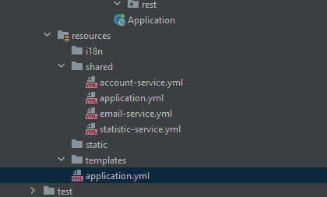

File **application.yml** in **shared** folder is used for all services in that folder: account-service, email-service, statistic-service, normally contains things like:

logging:  
 level:  
 ROOT: info  
 web.log.error.server: ERROR  
 web.log.debug.server: DEBUG  
 web.log.info.server: INFO  
 web.log.login.and.logout: INFO  
 file:  
 name: logs/be.log  
 logback:  
 rollingpolicy:  
 max-history: 7  
 max-file-size: 2MB  
  
  
springdoc:  
 swagger-ui:  
 path: /sw

after that, add: **@EnableConfigServer** in Class Application in central server

Then in the **resources-server** that we want to pull config from central server, we do these stuffs:

Dependencies:

<dependency>  
 <groupId>org.springframework.cloud</groupId>  
 <artifactId>spring-cloud-config-client</artifactId>  
 <version>3.1.1</version>  
</dependency>

Hoặc:

<dependency>  
 <groupId>org.springframework.cloud</groupId>  
 <artifactId>spring-cloud-starter-config</artifactId>  
 <version>${cloud-version}</version>  
</dependency>

In file application.yml, remove all curent config, add these:

spring:  
 application:  
 name: statistic-service (optional as long as matching with OPEN FEIGN)  
*# where to load configs* config:  
 import: configserver:http://localhost:8888 (8888 is port of CONFIG SERVER application)  
*# do not run server when config are not loaded* cloud:  
 config:  
 fail-fast: true